**Event Handlers from HTML**

**Basic**

* Create page containing only one button
* Toggle background color on button click



**Advance**

* Adapt basic example
* On button click, automatically toggle background
* Have a button to cancel automatic toggle



**Event Handlers Defined on DOM Elements (Chat Room)**

* Create chat room page containing
  + Input field for writing message
  + Button for sending message
  + Area for showing sent messages
* After the Send button is clicked, the message from the input field is moved to the area with all other messages

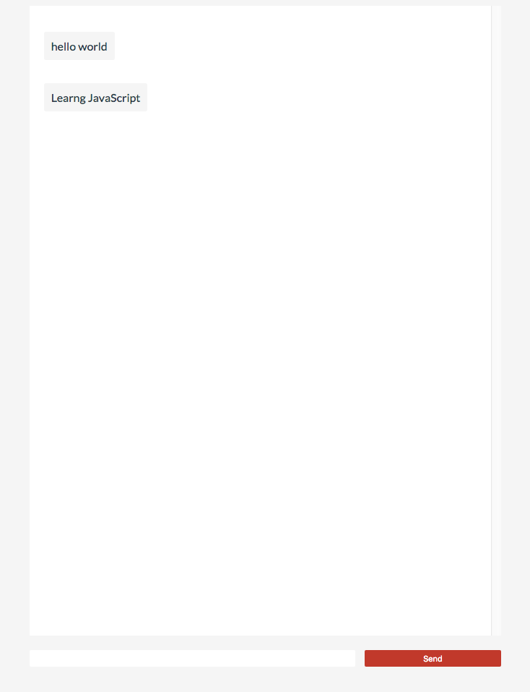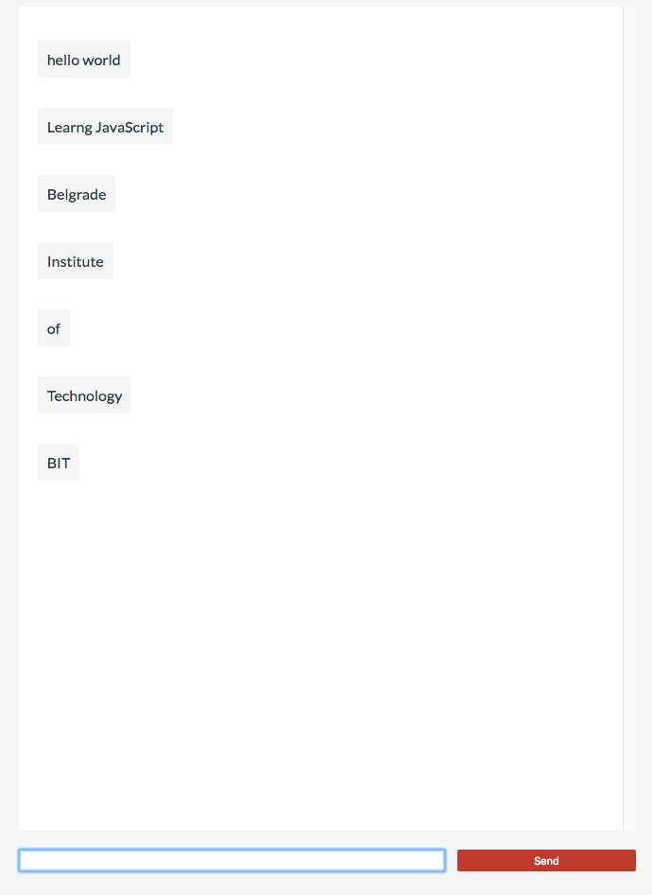

**Events using eventListeners**

**Soccer player**

* + Create page which has soccer field as bg image
  + In top left corner there should be image of soccer player
  + When user clicks anywhere on the field, the player is moved to that position
  + Add the button which is used to disable player movement
  + Images ( <https://goo.gl/YDjwi4> )

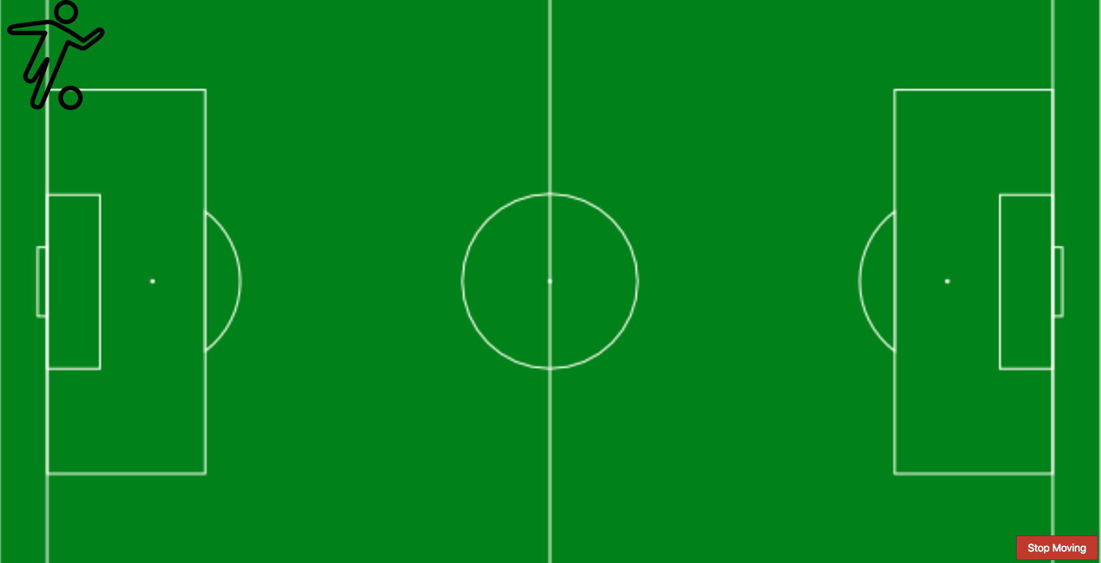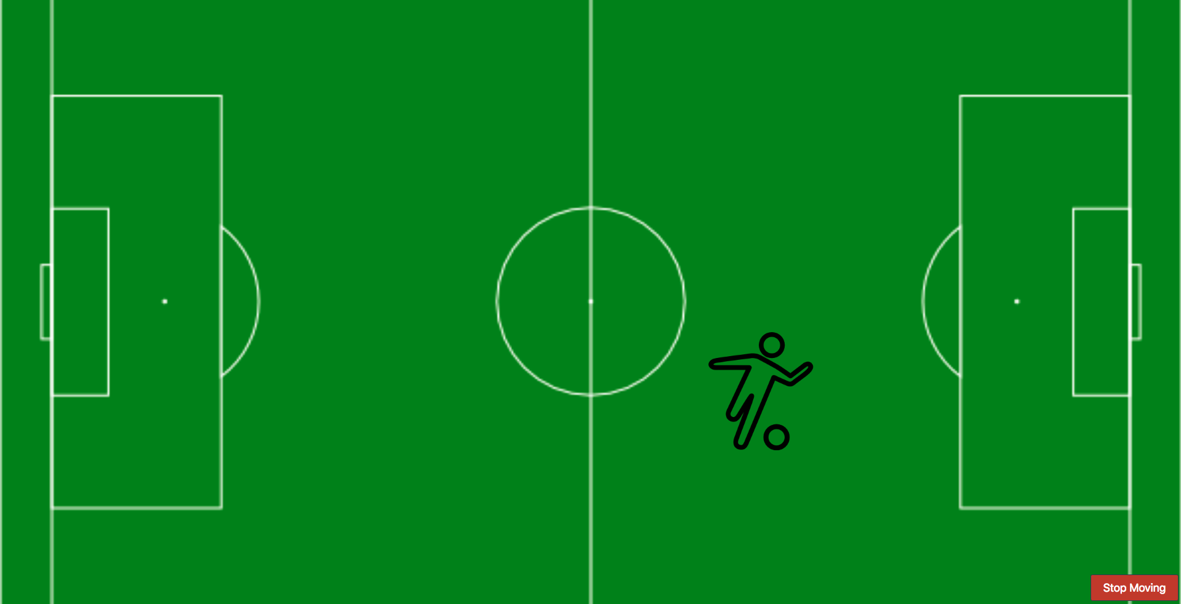

**Super Mario**

* + Create Super Mario emulator
  + On right arrow click, Mario should run to the right
    - Running animation
    - Ground should move while Mario is running
  + Images ( <https://rb.gy/23keik> )

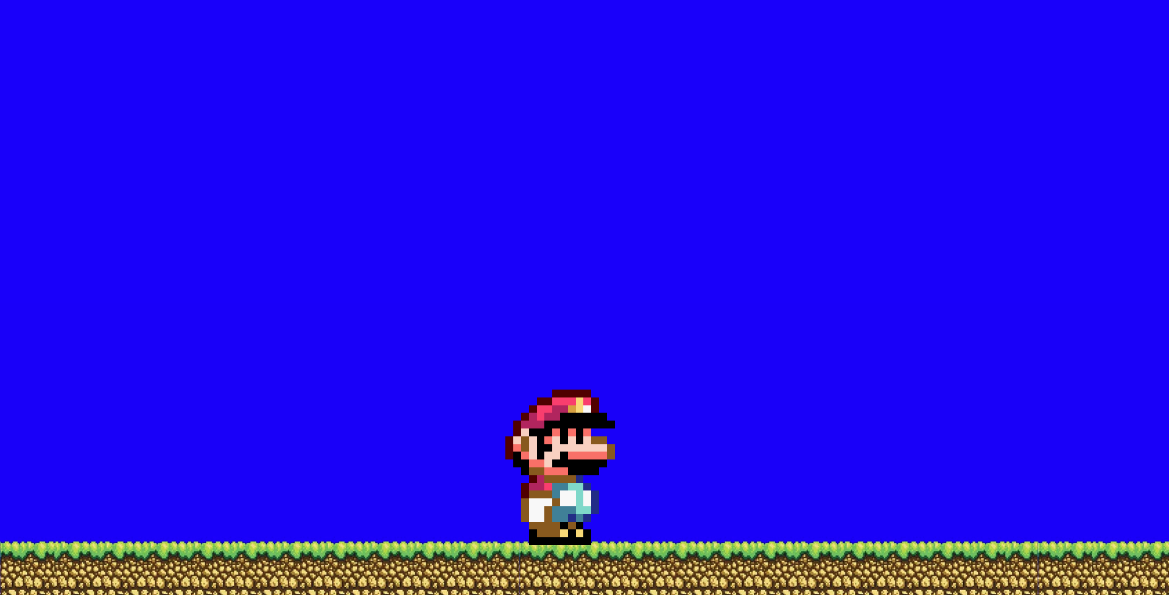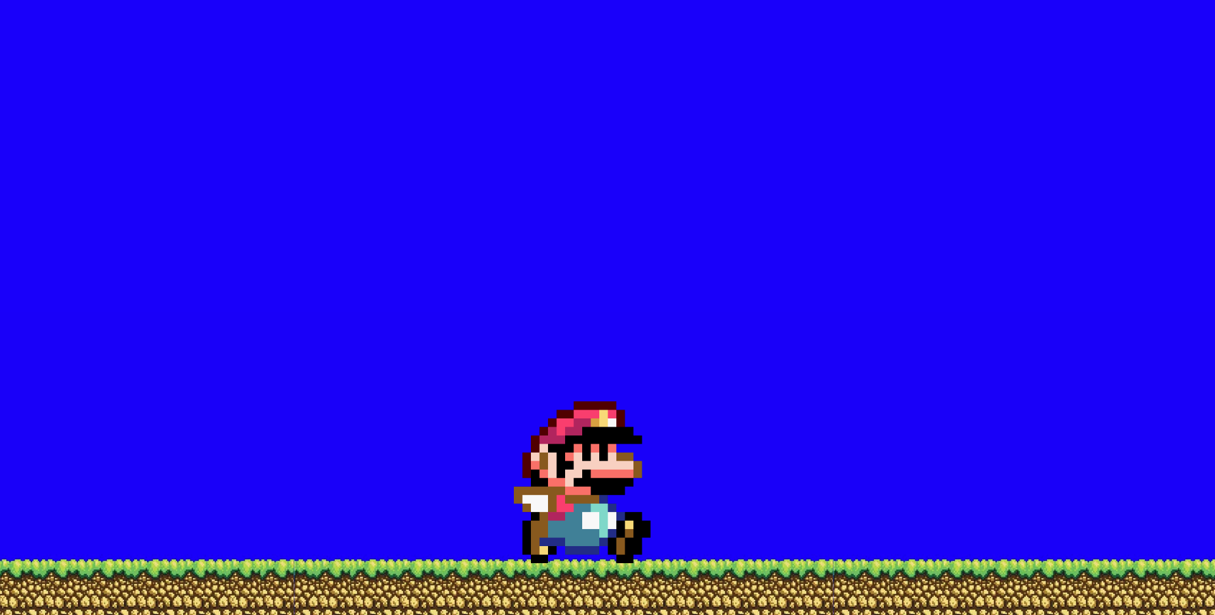

**Events propagation, stopping and preventing default**

Create page containing gallery

Gallery contains six pictures

At least one of the pictures should have width of 300px

Add event listeners to all images on page

User can click on image and in that moment image will get 1px red border

If Image width is not 300px event propagation should be stopped!

Register event listener on **document** object, which listen for **clicks**

When click occurs it should print in console on which element user clicked